Graph

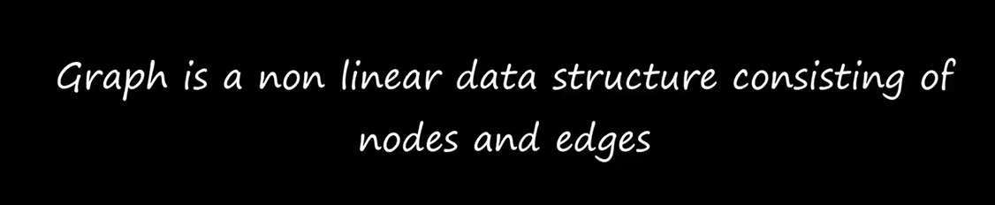

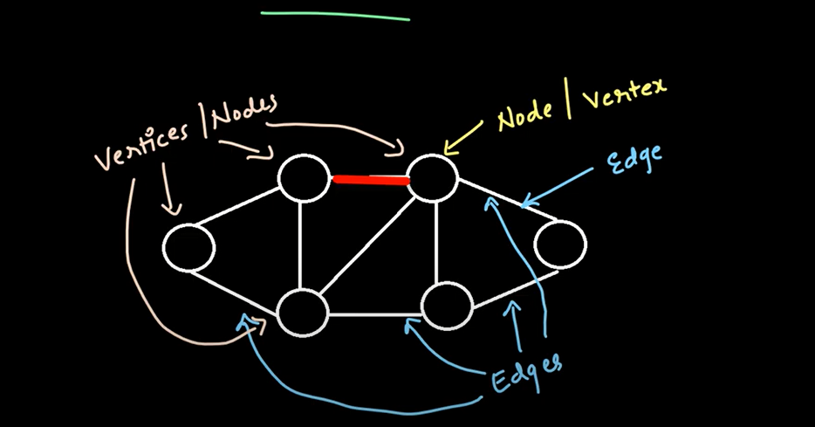

Edge is the line that connects any two nodes

A edge is a link or connection between any two edges

 Node- A vertex or node is the fundamental unit of which graphs are formed:

Difference Between Tree and Graph

Tree is a special type of graph. Tree will always be a graph but all graph will no be tree’s

Trees are a restricted type of graph

In Tree There is only one path from one node to another while in graphs there can be multiple paths from one node to another

In tree there are no cycle while graphs can have cycles

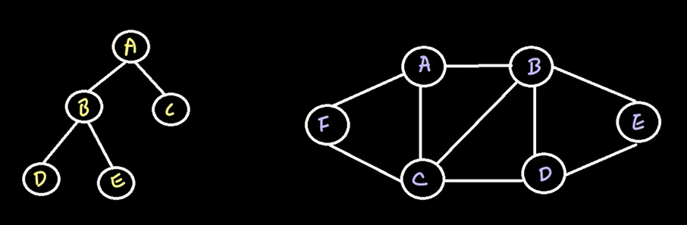Mathematically graphs can be defined as the ordered pair of vertices and edges

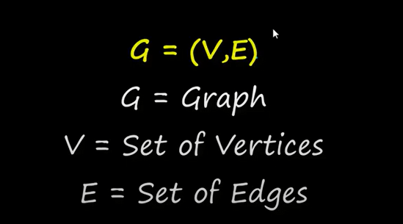

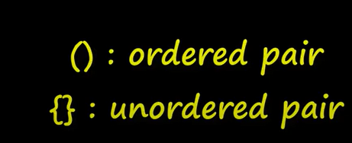

Uses of graphs

Maps

Social Media Websites in showing connections between users

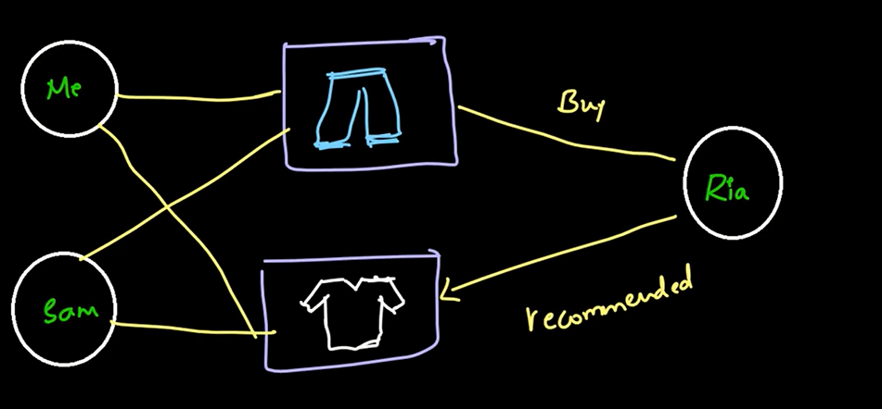E-commerce websites in recommendation system

Types of Graphs

Basis of Division

1. Direction of Edge
2. Weights of Edge
3. Cycles in Graph

Direction Of Edge

1-Directed Graph-A graph in which all the edges are unidirectional (Contains arrows on the edges)

2-Undirected Graph – A graph in which all the edges are bi-directional (No arrows on the edges)



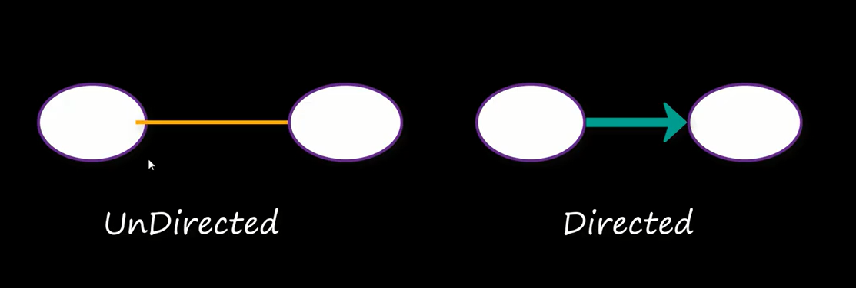

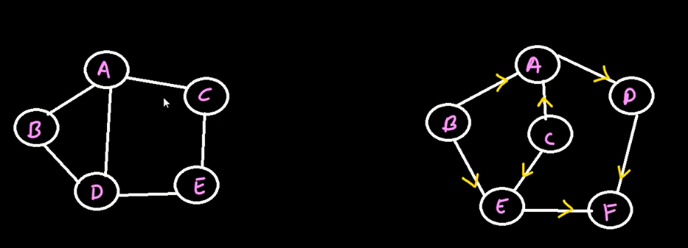

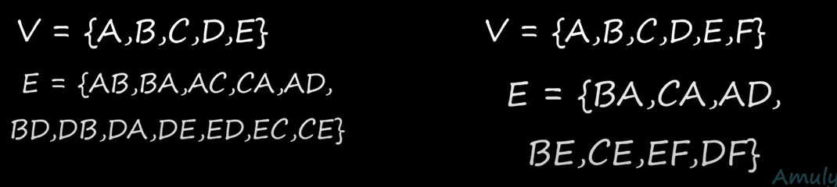

1. Weights of Edge



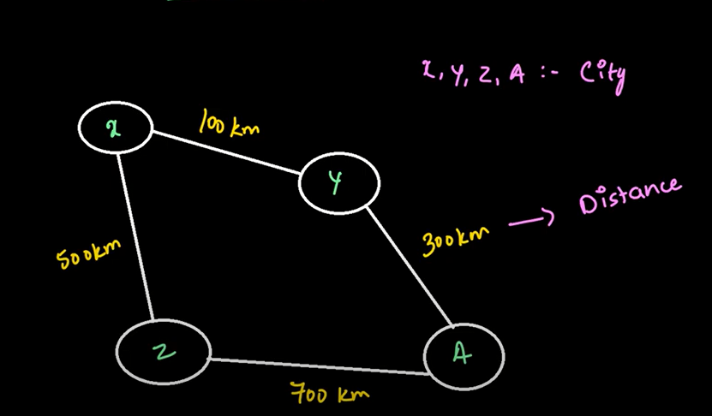

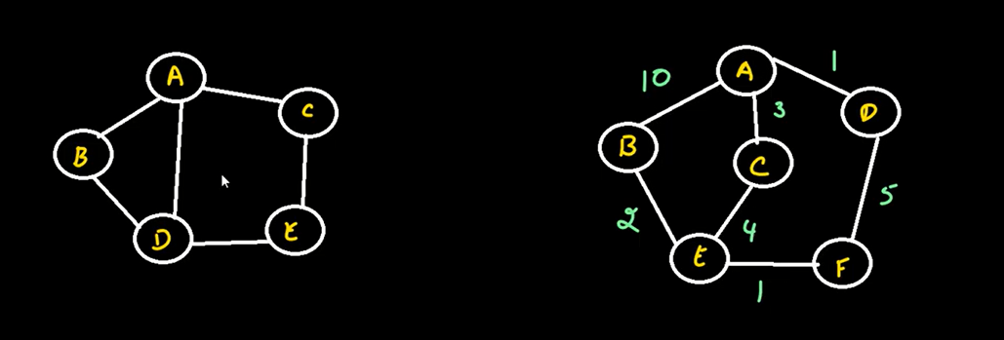

1. Cycles in Graph

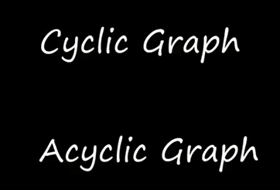

Cyclic Graph- A graph is said to be cyclic if it contains a path that starts from a vertex and ends at the same vertex

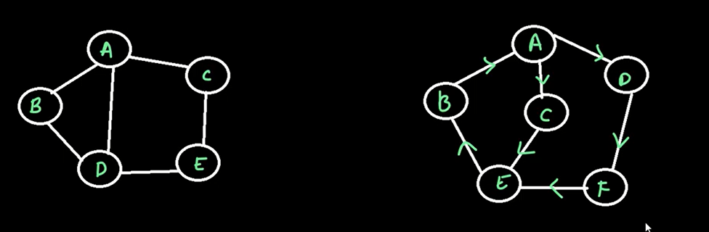

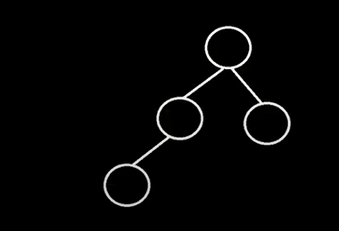Acyclic Graph- A graph is said to be acyclic if it does not contain any path that starts from a vertex and ends at the same vertex

More on Graphs

Adjacent Nodes/Neighbor Nodes

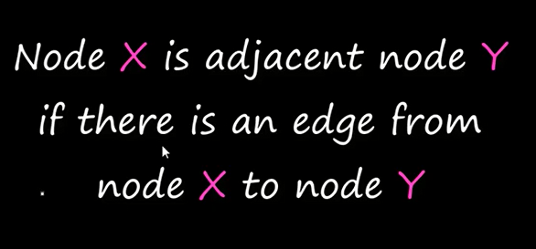

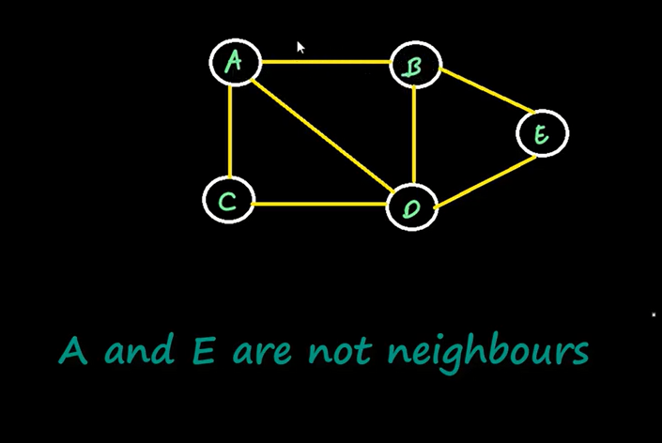

a path in a graph is **a sequence of edges which joins a sequence of vertices**

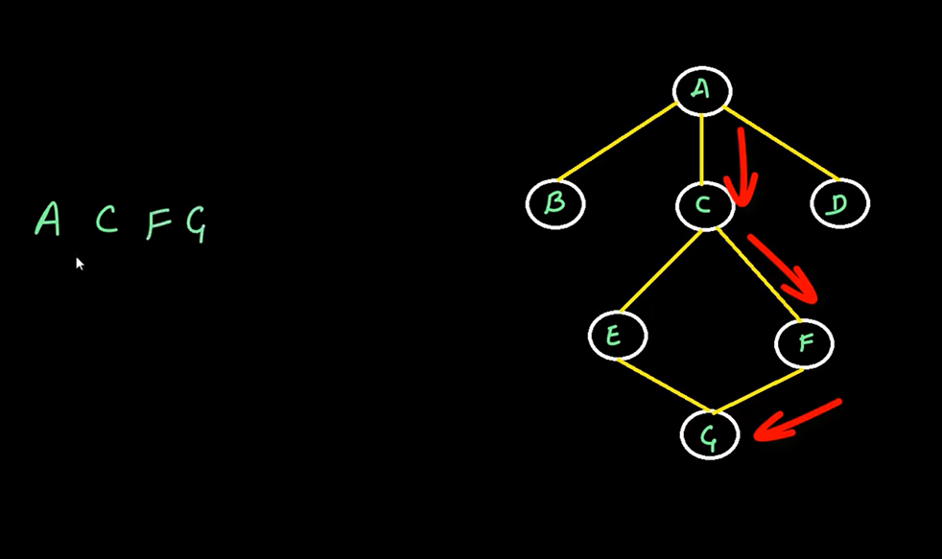

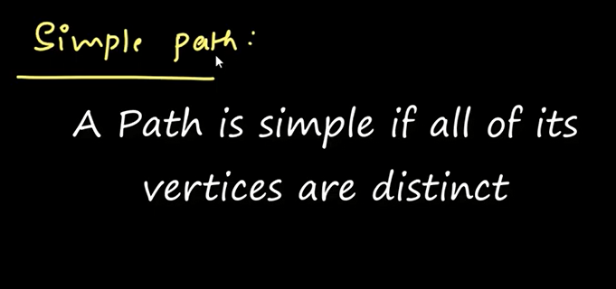Length of path is the number of edges in that path it cannot be less than or equal to zero

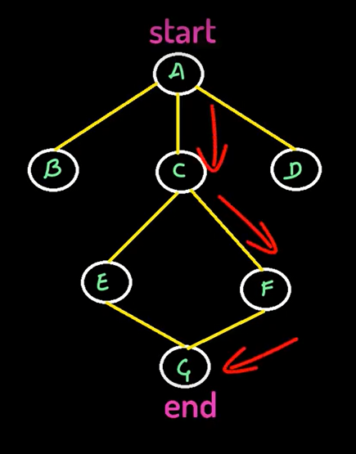

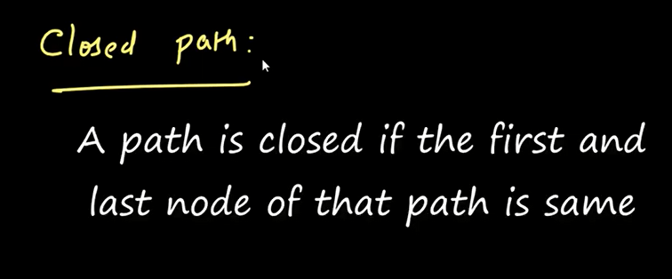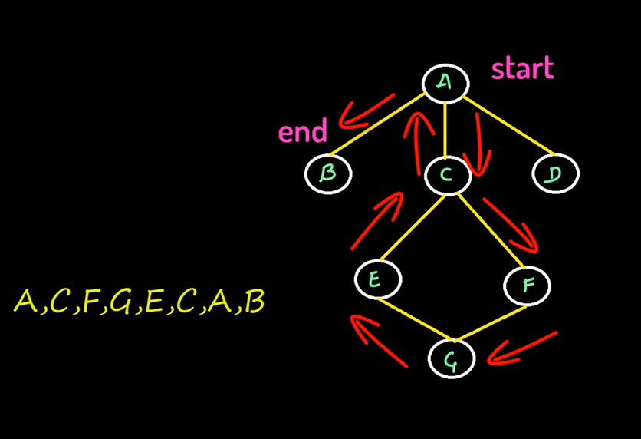Non – Simple Path

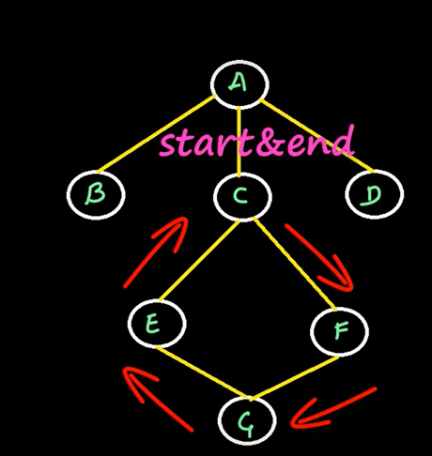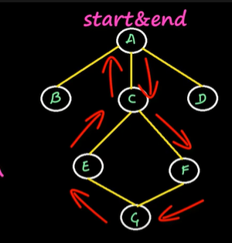 In closed path vertices can be repeated



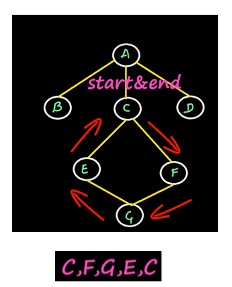It can also be called a cyclic graph

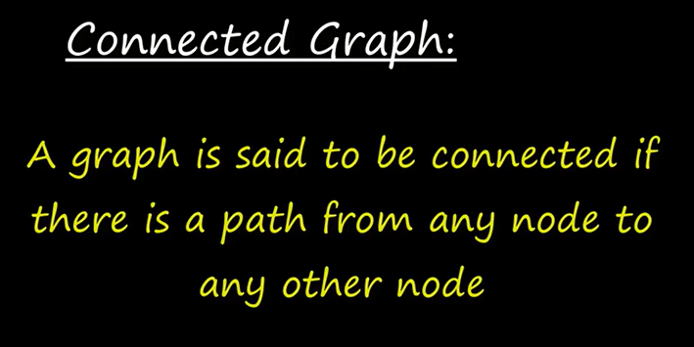

There should exist a path between every pair of node

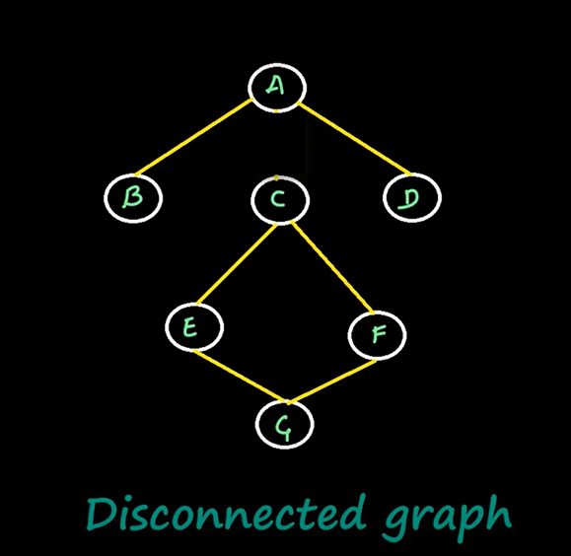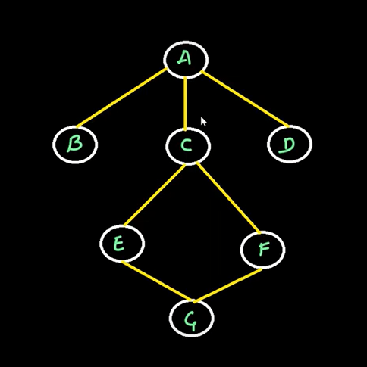

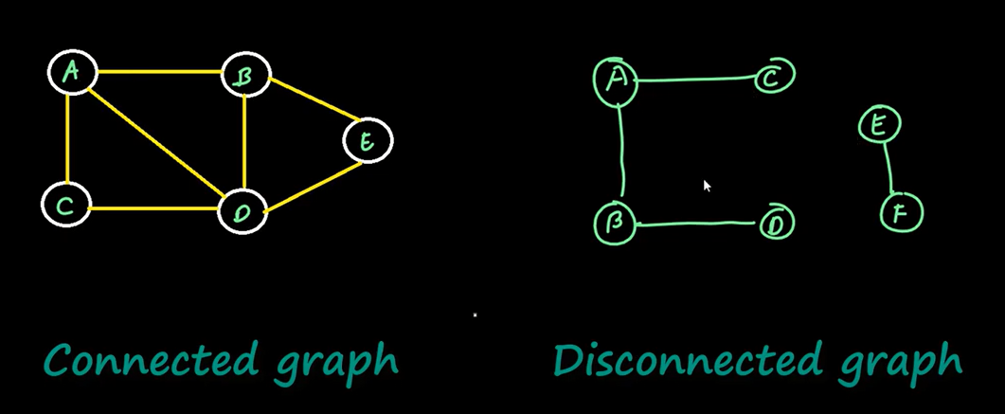

The term connected and disconnected can be used for undirected graphs

In case of directed graphs we will use strongly connected graph and weekly connected graph

DIRECTED GRAPH can also be termed as digraph

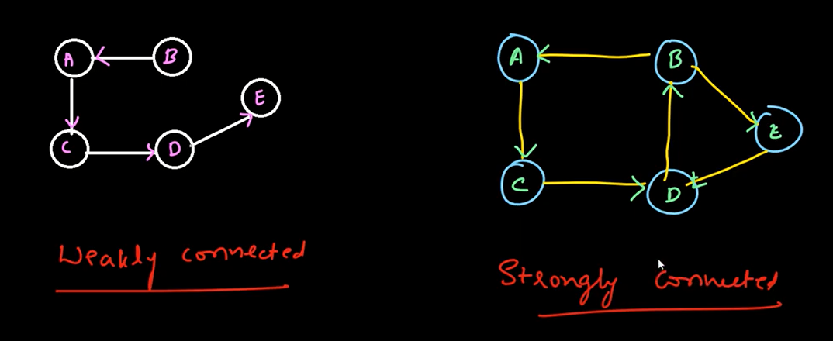

Strongly Connected

Degree of a node

Undirected graph

Directed Graph



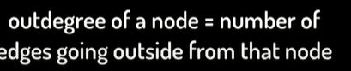

Representation of Graph in Computer Memory

1-Adjacency Matrix

2-Adjacency List

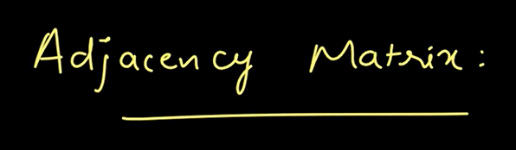

Adjacency matrix is a matrix representation of exactly which nodes of the graph contains edges between them



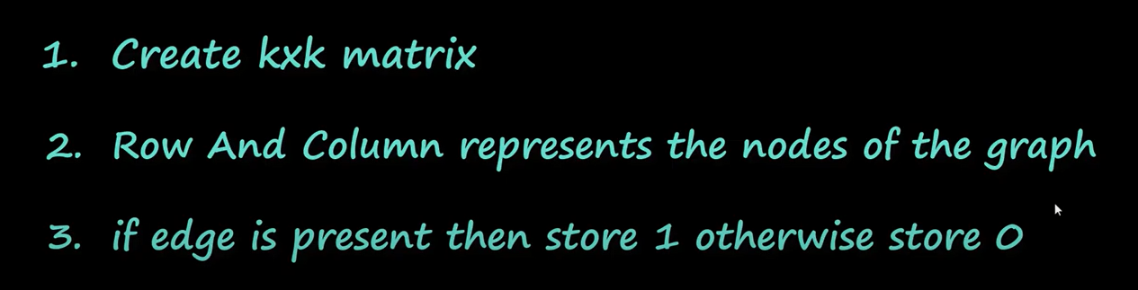

K is the number of nodes in the graph

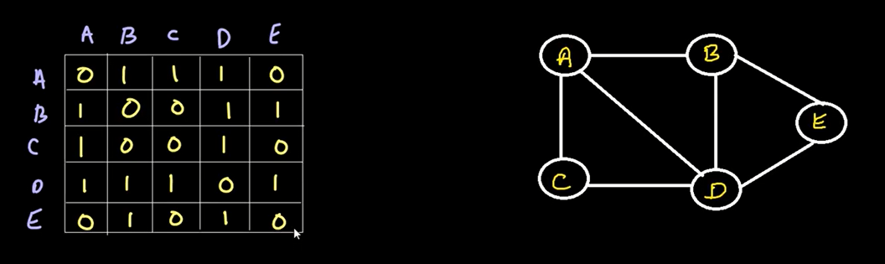

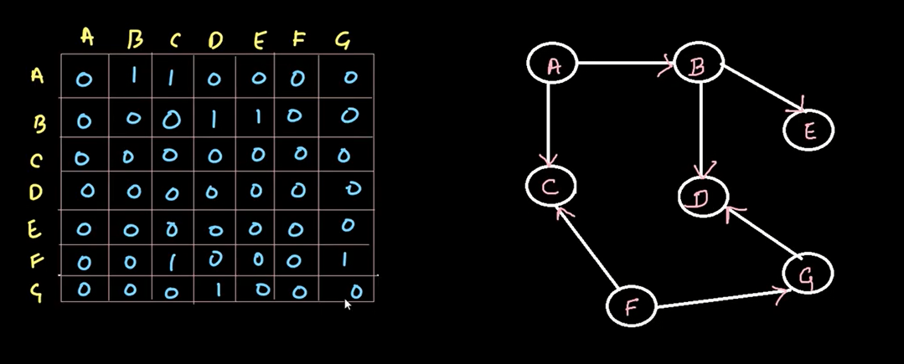

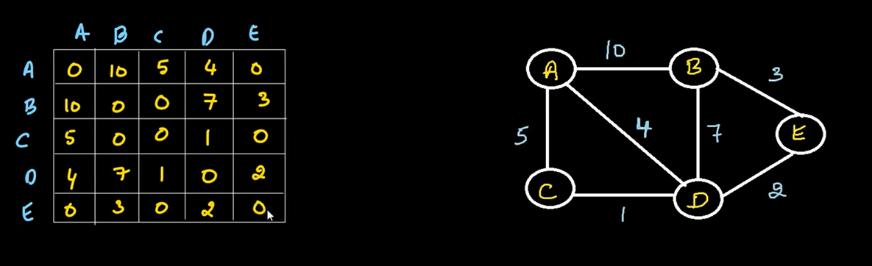

Disadvantage

Takes a lot of memory

Dense matrix – with only a few zeros

Sparse Matrix – matrix with a lot of zeros



